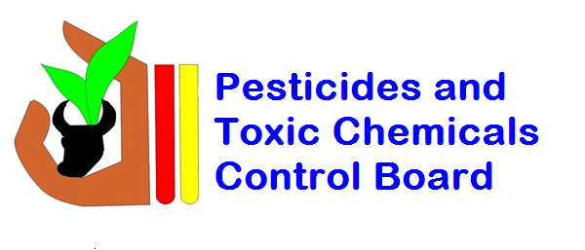

Ministry of Agriculture
Pesticides and Toxic Chemicals Control Board
Pest Control Applicator Intermediate Proficiency Training
REGISTRATION FORM
Instructions:
- Please fill out all required fields in the registration form with accurate information.
- Attach a copy of any form of identification. It can be a copy of your Driver’s License, Passport or National Identification Card
- Email the completed form along with your identification card to secretary@ptccb.org.gy and tjordon@ptccb.org.gy
Personal Information
Gender: | Female: |  | Male:
First Name:
Last Name:
Date of Birth (dd/mm/yy):
Address:
Contact Number:
E-mail:
Identification Number
(Driver’s License / Passport / National Identification Card):
Education: | Primary | Secondary |  | Tertiary
Professional Information

Company Name:
Designation:

Ministry of Agriculture

Emergency Contact Information

Name of Person:
Contact Number:
Cost for Registration

GYD $10,000
(For Registered Pest Control Operators)

GYD $20,000
(For Individuals OR Private Companies)

Please select your meal preference: | - Vegetarian  - Non-Vegetarian  - Other (please specify): _______________________________________

Note: Payment options include cash or cheque. Cheques must be written to the Pesticides and Toxic Chemicals Control Board

Date: __________________ Signature of Applicant: _________________________

